Do

Members:

1. Mohammed Aljoudi
2. Mohammed Alothman
3. Mohammed Aljaafari
4. Mohammed Alghunaim
5. Faleh Al-KHALDI

Description :

We are trying to build a web app that organizes the workload on students or employees and to visualize the process on the timeline.

Use case diagram: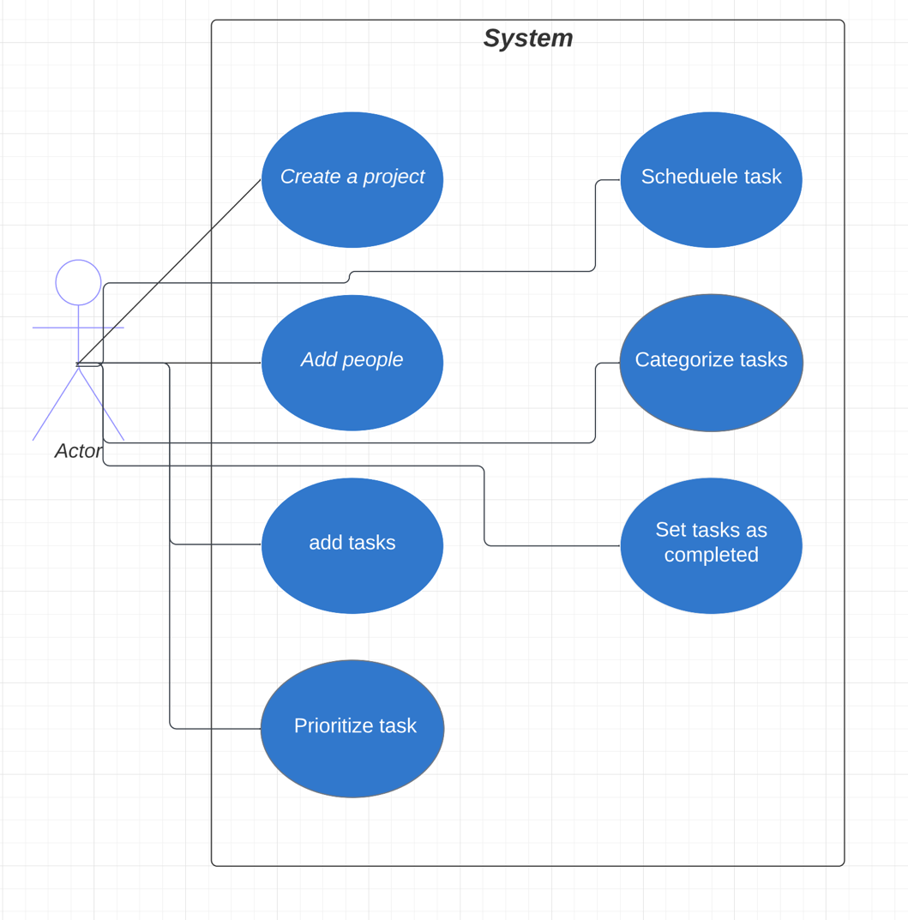

Scenarios :

1. User clicks on the create project in the main page
2. In the project page, the user will have a button for adding members to the project followed by their names.
3. In the project page, user will be able to add tasks to specific members or general ones.
4. In the project page, when adding tasks, tasks can have priorities (High, medium,low) etc. .
5. When adding tasks, a scheduling option is clicked followed by the wanted date to do the task.
6. In the project page, select the tasks and then group them in a container then set the name for that container.
7. Each team member can click the checkbox for each task.